

DEPARTMENT: SOFTWARE ENGINEERING
COURSE: SOFTWARE CONSTRUCTION AND DEVELOPMENT
BS-SE 5th
LAB REPORT
LAB: 12
SUBMITTED TO: MA’AM SAIQA ANJUM
SUBMITTED BY: AIZA HASSAN
ROLL NO: RCS-30244
DATE: 6th-MAY-2026

“LAB TASKS”

1. Setup Initial Test Structure Create a basic test structure for a simple function or class. Write a test that verifies a basic functionality (e.g., a function that adds two numbers).
Setup Initial Test Structure
Project structure
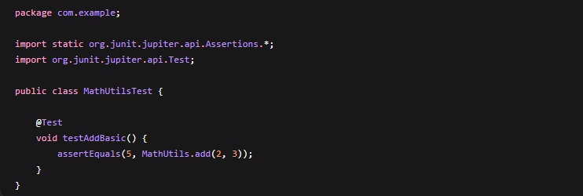

2. Write a Failing Test Write a test that initially fails because the code under test is not yet implemented. Write a test case that expects a certain behaviour from the code (e.g., expecting a function to return a specific result).
The Failing Test
Right now, MathUtils class or add() method does NOT exist.
When we run tests, we’ll get a compile error like:
error: cannot find symbol
symbol: method add(int,int)

3. Implement Minimum Code to Pass Test Implement the minimum code necessary to make the failing test pass. Write the code to fulfill the requirements of the test case, ensuring it passes the test without adding unnecessary complexity.
Implementing Minimum Code to Pass Test
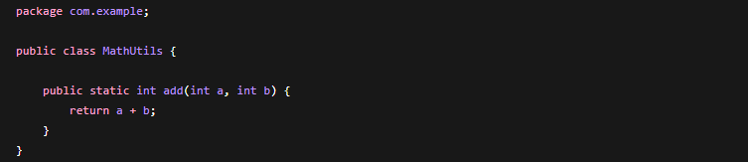

4. Refactor Code Refactor the code to improve design, readability, and maintainability. Review the implemented code and refactor it while ensuring all tests continue to pass. Remove duplication, improve naming, and apply best practices.
Refactor Code
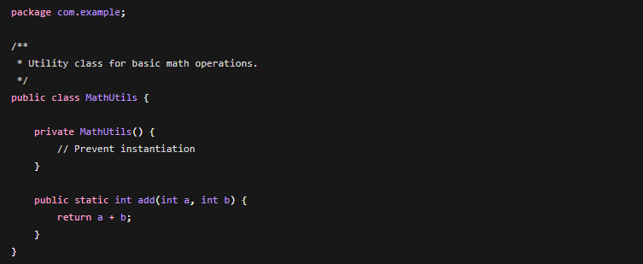

Improved Test Cases
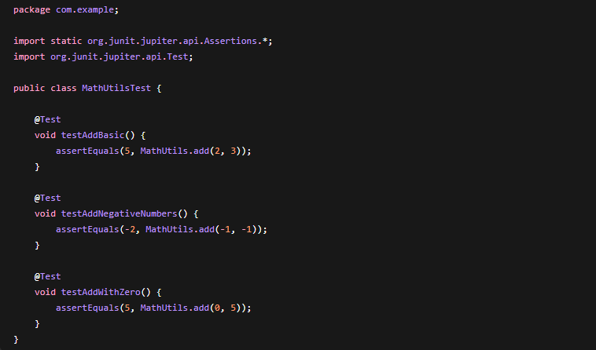
Summary (TDD Cycle)
- Red: Test fails (method not implemented)
- Green: Add minimal code to pass.
- Refactor: Clean code + improve tests.

